**HTML Editors**

**Coding In Notepad:**

A simple text editor is all you need to learn HTML.

we use "Notepad" to learn HTML as a beginner.

But professional websites have been created and modified by using “Professional Code Editors”.

**4 Steps to Code:**

There are 4 steps to code HTML in notepad file.

**Step 1: Open Notepad**

Open Notepad in your computer or laptop by following steps:

* Go to the “Search Bar” in windows that is located in the left of the “Taskbar”
* Search “Notepad”, and you will see a “Notepad Option” appears at the top
* Just click on it
* Then notepad will be open in your computer

**Step 2: Write HTML Code**

Write the below HTML code in notepad:

**Code:**

<!DOCTYPE html>

<html>

<body>

<h1>My First Heading</h1>

<p>My first paragraph. </p>

</body>

</html>

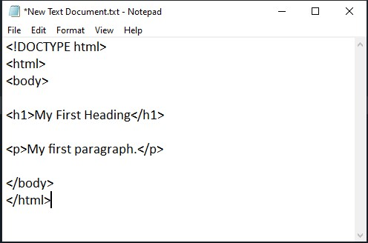

**Step 3: Save the Notepad File**

Save the Notepad File at your desired location in your computer by following steps:

* Press “ctrl + s” to save the file
* Give the name “index” to this notepad file
* Change the extension of notepad file to “.html”.

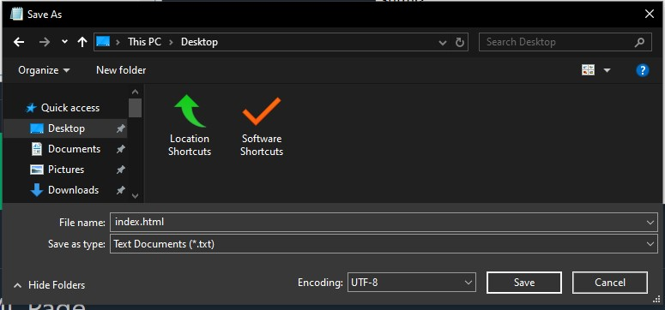

**Step 4: Check the Output**

View the output of HTML file in your “Browser” by following steps:

* Double click on the HTML file or “.html” file.
* It will open in the browser whatever you have installed in your computer like “Google Chrome”
* You can see the output of your HTML file.

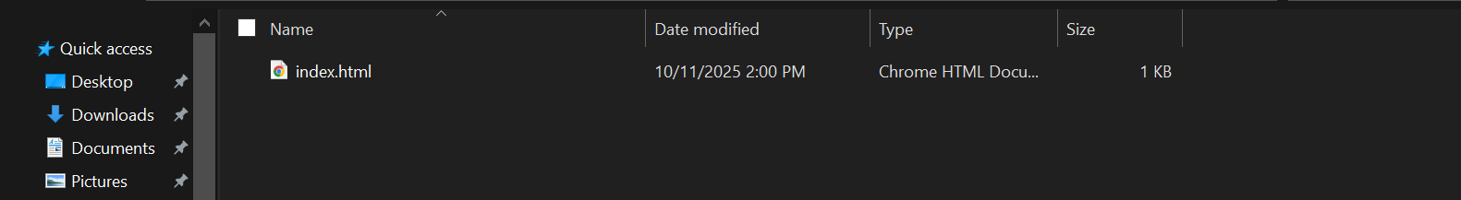**Double** **on the below file in your computer:**

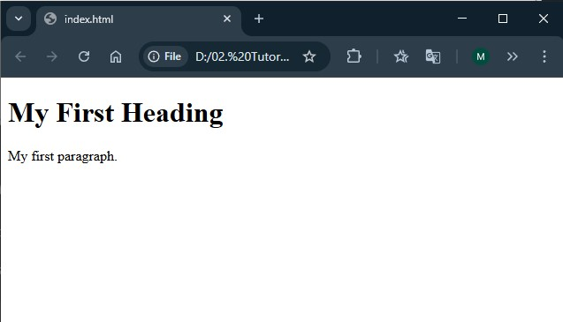**See the output:**

**Extensions of HTML File:**

There are 2 extensions of HTML file:

* .htm
* .html

we can save the HTML file with ".htm" or ".html" extensions.

There is no difference, it is up to you.

But it is recommended to use ".html" file extension.